Report of the MSG Retreat Held in Buchanan City, Grand Bassa County from December 15-17, 2025 at Charlie Lodge Conference Hall

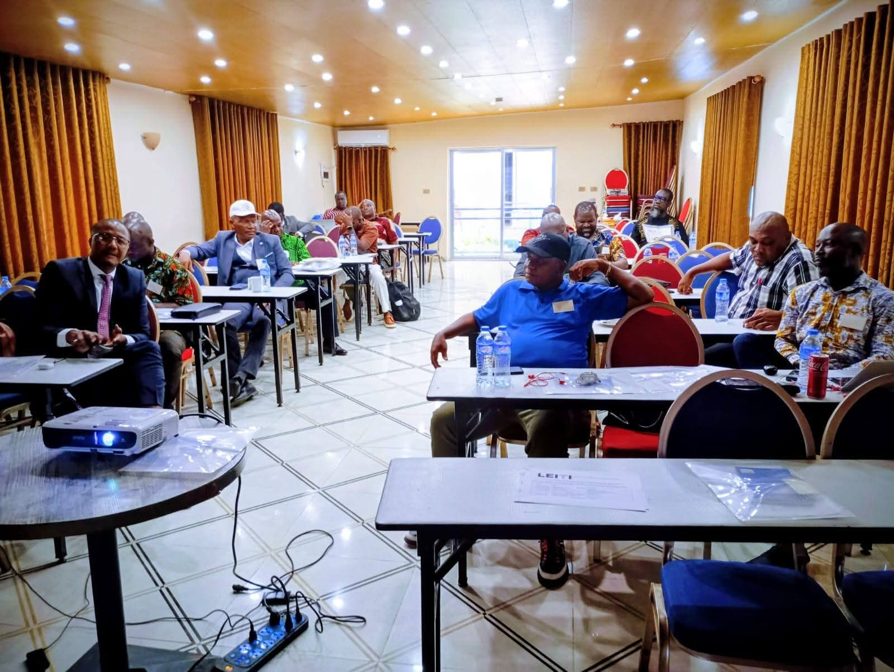

Approved: December 30, 2025

Table of Contents
Objectives of the Retreat 3
Stakeholder Representation 3
MSG Retreat Attendance 3
Opening of the Retreat and Adoption of the Retreat Agenda 4
Welcome Remarks from the Chairman 4
Purpose of the Retreat 4
Self-Introduction 5
Overview of the New EITI Validation Guide 5
MSG Members’ Comments after the New Validation Guide Presentation 5
Presentation of the Validation Templates to the MSG 6
Review of MSG Attendance Record 6
Changing of MSG Members 7
Special Remarks by Representative Sam P. Jallah 7
Presentation of LEITI’s Draft Five-Year Strategic Plan 7
MSG Review of Progress and Challenges 8
MSG Decisions at the Retreat 9

Objectives of the Retreat
The retreat aimed to review and approve Liberia’s Validation templates, orient the MSG on the new EITI Validation Guide in greater depth, and approve the LEITI’s 2026-2030 Strategic Plan. Additionally, the retreat also sought to provide the MSG with an opportunity to review progress, identify challenges, and propose a way forward to improve EITI implementation in Liberia.

Stakeholder Representation
Sixteen members of the Liberia Extractive Industries Transparency Initiative Multi-Stakeholder Group attended the MSG retreat in Buchanan City, Grand Bassa County. Eight representatives from the Government Bloc, three from the Private Sector Bloc, and five from the Civil Society Bloc. The gender breakdown at the retreat was 15 males (94%) and one female (6%).

MSG Retreat Attendance
No. | Name of MSG Member/Alternate | Institution | Contact
1. | Samuel Summerville | Ministry of Mines & Energy(MME) | 0886531988
2. | Fabian M. Lai/Emmanuel Azango | National Oil Company of Liberia(NOCAL) | -
3. | Sam P. Jallah | House of Representatives(HOR) | 0777077080
4. | Kwame Ross | The Liberian Senate
5. | Atty. J. Alben Greaves | Ministry of Justice(MOJ) | 0776469524
6. | E. Ekema A. Witherspoon | Forestry Development Authority(FDA) | 0886517811
7. | N. Rufus Scott | Liberia Petroleum Regulatory Authority(LPRA) | 0776465053
8. | Ekema Witherspoon II | Liberia Revenue Authority(LRA)
9. | Cecelia T. Danuweli | Publish What You Pay Liberia Coalition(PWYP-Liberia) | 0886572696
10. | Winston W. Wreh | Liberia Labor Congress(LLC) | 0776147982
11. | Amb. George N. Kingsley | National Civil Society Council of Liberia(NCSCL) | 0886601991
12. | James M. Strother | Liberia Business Association(LIBA) | 0775843067
13. | Abraham B. Gappie | Mineral Civil Society Organizations of Liberia(MICSOL) | 0555771912
14. | Stanley Whelzar | Liberia Timber Association(LibTA) | 0777203822
15. | Nathaniel T. Blama | Liberia Chamber of Mines | 0777518635
16. | Elvis G. Morris | Liberia Agriculture Company Association(LACA) | 0886424335
LEITI Secretariat Staff
1. | Jeffrey N. Yates | LEITI Secretariat | 0770167440
2. | Zaza Y. Quaqua | LEITI Secretariat | 0777060350
3. | George N. Dennis | LEITI Secretariat | 0770426847
4. | McDonald S. Kerl, Sr. | LEITI Secretariat | 0886492515
5. | Christine Humaru | LEITI Secretariat | 0770187196
6. | Reuben Freeman | LEITI Secretariat | 0776557728

Day One: December 15, 2025

Opening of the Retreat and Adoption of the Retreat Agenda
The MSG retreat commenced at 10:00 am, with the MSG Chairman's proxy, Mr. Samuel Summerville, officially opening the retreat and calling for a motion to adopt the agenda. Mr. Fabian M. Lai, President and CEO of the National Oil Company of Liberia (NOCAL), requested that the start time for the retreat listed on the agenda be changed from 10:00 am to 9:00 am.
Additionally, an amendment to add a tour of Buchanan by the MSG to the agenda was proposed by Atty. J. Alben Greaves of the Ministry of Justice, who represented the Minister and Attorney General.
A motion to adopt the agenda with the proposed amendments was made by the proxy of the MSG Chairman, Assistant Minister Samuel Summerville, and seconded by Mr. Rufus Scott of the Liberia Petroleum Regulatory Authority (LPRA). With the motion being seconded, the agenda was endorsed by the Body to guide the MSG throughout the retreat.

Welcome Remarks from the Chairman
Mr. Samuel Summerville, proxy of the MSG Chairman Hon. Matenokay Tingban, welcomed all MSG members on behalf of the Chairman, thanked them for allotting time to be in Buchanan for the MSG retreat, and stated that the retreat was an opportunity for the MSG to review progress around EITI implementation, identify challenges, and make plans for improving EITI implementation in Liberia.

Purpose of the Retreat
The Head of the LEITI Secretariat reminded members of the MSG that Liberia will undergo EITI Validation in January 2026 under the new 2023 EITI Standard. He stated that following the last Validation of Liberia, we obtained a score of 75.5, which indicates “Moderate”. He informed the MSG that they have made significant progress since the last Validation. According to the Head of Secretariat, Liberia has addressed all fourteen (14) Corrective Actions from the last Validation that took place in 2022. He expressed confidence that Liberia could exceed the score from the last Validation, given the collective efforts of the MSG and the Secretariat. He also informed the MSG that the validation templates are numerous and that it would be prudent for the MSG to review key aspects of all templates and provide approval.
According to the Head of Secretariat, the Validation Team will hold stakeholder engagement in March 2026 to discuss the implementation of EITI in Liberia and the independence of civil society to participate in the EITI process. He stated that this retreat was an opportunity for civil society members on the MSG to understand some of the questions the Validation Team will ask and to be aware of the required responses to corroborate what they intend to approve in the templates.
The HOS concluded by informing the MSG that the final aspect of their presence in Buchanan for the retreat was to bring the MSG together to review their progress on EITI implementation and suggest ways to improve it in Liberia in the coming year.

Self-Introduction
Following the Head of Secretariat's purpose for the retreat, it was time for self-introductions per the approved agenda. All MSG members and proxies introduced themselves and the institution they represent on the LEITI MSG.

Overview of the New EITI Validation Guide
The Head of Secretariat delivered a PowerPoint presentation to the MSG providing an overview of the EITI Validation Guide. During his presentation, he highlighted key aspects of the Validation Guide, drawing comparison to the last Validation under the 2019 Standard. He indicated to the MSG that EITI Validation, past and present, covers three key components: Stakeholder Engagement, Transparency, and Outcomes and Impact. He explained which areas of the EITI Standard each component of the Validation templates covers. According to him, Stakeholder Engagement assesses EITI Requirements 1.1 to 1.4, including the EITI protocol on civil society participation, examining the participation of constituencies and multi-stakeholder oversight throughout the EITI process.
He stated that the Transparency component assesses EITI Requirements 2 to 6, evaluating whether the country meets the disclosure requirements of the 2023 EITI Standard, including the timeliness, comprehensiveness, and reliability of information published in EITI reports; while the Outcomes and Impact component assesses EITI Requirements 7 and 1.5, focusing on the country addressing national priorities and facilitating public debate. According to him, it assesses whether a country’s EITI implementation objectives align with national priorities and evaluates stakeholder feedback on achieving them. Furthermore, he stated that this component also examines the outcomes and impact of EITI implementation, as well as opportunities to improve its effectiveness.
He then presented Liberia’s most recent Validation report, highlighting areas of progress and challenge. He highlighted the issue of transparency, emphasizing contract transparency, production and export data, BO transparency, and state participation. He explained the EITI Validation grading system to the MSG and indicated that the country was targeting a “very good” (80-90) score in the coming Validation, as agreed by the Body.

MSG Members’ Comments after the New Validation Guide Presentation
Elvis Morris, Vice President for Strategy, Sustainability, and Stakeholder Engagement at Golden Veroleum and a representative of the Liberia Agriculture Company Association (LACA) on the LEITI MSG, stated that their industry is engaged in the EITI process in Liberia, as demonstrated by their compliance, participation, and ongoing engagement with LEITI. He said that at every forum, they encourage their members to comply with the LEITI process in Liberia. He concluded by reminding the Government of the challenges facing communities and the need to act to ensure a stable environment for companies to operate.
Also offering his view, the President of the Liberia Business Association, Mr. James M. Strother, stated that the private sector is engaged and that investors are now encouraged to enter the sector due to the current level of improvement. The HOS accepted their comments on industry engagement and committed to incorporating them into the templates, reflecting the views of industry stakeholders.

The representative of the Chamber of Mines, Mr. Nathaniel Blama, urged the Head of Secretariat to share the current challenges related to the Validation with the MSG so they can help address them and support the Country. He cautioned that outlining the challenges is not enough; efforts must be applied to address them, noting that the Secretariat alone cannot solve them; MSG members can help by leveraging their influence.
On the issue of NOCAL’s unpublished audited financial statement for the year 2023, the President and CEO of NOCAL, Mr. Fabian M. Lai, stated that there needs to be a balance between the GAC’s audit and that of private firms, indicating that the GAC usually focuses on transactional audit, but the EITI wants more than that.

Presentation of the Validation Templates to the MSG
Making his second presentation of the day, the Head of Secretariat, Jeffrey N. Yates, drilled the MSG through key aspects of the templates, highlighting key areas in the templates to include:
- Publicly Available MSG Members List
- MSG Committees Establishment
- Ad hoc Committee
- Gender Balance on the MSG
- Legal Basis of the MSG
- MSG Terms of Reference
- LEITI Outreach with CSOs and Companies Involvement
- Work Plan Approval and Monitoring
- Energy Transition
- Procedure for MSG Nomination, Tenure, and Decision-making on the MSG
- Payment of Honorarium to MSG Members
- Outcomes and Impact
- Stakeholder Engagements
- Transparency

Following the Head of Secretariat's presentation of the templates, the MSG unanimously approved the templates.

Review of MSG Attendance Record
The Head of Secretariat presented the attendance record for all MSG members for MSG review. Following a thorough review and a few corrections, the MSG agreed that, in the future and in the interest of institutional representation, when a proxy attends, the principal should be considered to have done so.

Changing of MSG Members
Having reviewed their attendance record and deliberated on the tenure of MSG members and the process for their replacement, the MSG agreed that, for those from the Government Bloc, the change of member should be described as a “change of appointment”. In contrast, for the Civil Society and Company Blocs, it should be described as “end of tenure”.

Special Remarks by Representative Sam P. Jallah
Before the close of the MSG session for day one, the presiding officer of the session provided the opportunity for special remarks. Representative Sam P. Jallah (Chairman of the House Committee on Natural Resources) appreciated the MSG for the retreat and promised to always be at every MSG meeting except when he’s out of the country. He pledged his unflinching support for the EITI process in Liberia and committed to ensuring that LEITI receives the necessary legislative support to fulfil its statutory role.
The Head of Secretariat announced, as a reminder, that tomorrow’s MSG session will examine:
- LEITI Strategic Plan (2026-2030)
Following the HOS's announcement, the Presiding called for a motion to adjourn the session for the day. Mr. Nathaniel Blama moved to adjourn the session, and Amb seconded—George N. Kingsley of the National Civil Society Council of Liberia.

Day Two: December 16, 2025
The second-day session of the MSG retreat began with the Presiding calling the session to order and requesting that the Head of Secretariat read the agenda for the day. With the agenda read, the Head of Secretariat suggested that today’s session begin with the MSG reviewing the LEITI Five-Year Strategic Plan, followed by an examination of progress and challenges in EITI implementation. Mr. Fabian M. Lai also requested that the HOS’s proposal include adjusting the session start time from 10:00 am to 9:00 am, and it was included.
Following the HOS’s suggestions, the following motions to amend the agenda were made, seconded, and endorsed by the Body:
- A motion to accept the amendment proposed by the HOS was made by Mr. Nathaniel Blama of the Chamber of Mines and seconded by Madam Cecelia Danuweli of Publish What You Pay (PWYP) Liberia Coalition.

- A motion to adjust the departure time of the day from 5:00 pm to 1:00 pm was made by Mr. James M. Strother of the Liberia Business Association and seconded by Mr. E. Ekema Witherspoon of the Forestry Development Authority.

Presentation of LEITI’s Draft Five-Year Strategic Plan
The HOS presented the draft five-year strategic plan for MSG’s review and input. However, before reviewing the plan's activities, Mr. E. Ekema Witherspoon of the FDA raised concerns about the plan's duration. According to him, since the strategic plan is aligned with the AAID, it should expire with the AAID and not go beyond 2029.
The HOS indicated that, in 2030, the government will still be developing a new agenda, and that there will be no national agenda to conflict with the old.
Mr. Nathaniel Blama suggested extending the strategic plan to 10 years. Meanwhile, Mr. Kwame Ross stated that the five-year Strategic Plan is acceptable. He noted that, over the next year, the review will cover the previous four years; it doesn't matter which government is in power.
The HOS highlighted the following about the strategic plan
- The alignment of the Five-Year Strategic Plan with the LEITI Act, the 2023 EITI Standard, and the AAID
- The Plan aligns with three pillars of the AAID( Governance & Anti-Corruption, Economic Development, and Environmental Sustainability)
- Objective of the Strategic Plan
- SWOT Analysis (The MSG discussed lengthily the powers and limits of LEITI as provided for in its Act, and briefly the salary structure of the Secretariat staff)
While reviewing the actual activities in the work plan, with emphasis on activities, costs, and schedule of implementation, the MSG members made the following points:
- That training for MSG members should focus on understanding the EITI reports
- Elvis Morris offered to do the concessions map for LEITI at no cost
- To construct a modern head office with a parking lot, LEITI will need at least one million United States Dollars, according to Mr. Nathaniel Blama of the Liberia Chamber of Mines
- Mr. James M. Strother recommended that the head office be located in Bentol City, since the ocean is reducing the City of Monrovia.
At this point, the Head of Secretariat informed the MSG that there will be a mid-term review of the Strategic Plan, as the activities are not yet finalized.
The Chairman then moved to endorse the Strategic Plan, which the MSG had exhaustively reviewed. Mr. Emmanuel Azango of NOCAL moved that the Strategic Plan be accepted and approved. Madam Cecelia Danuweli of PWYP seconded his motion.
The MSG then approved the LEITI Five-Year Strategic Plan.

MSG Review of Progress and Challenges
The MSG acknowledged progress in Liberia's EITI implementation, noting that any MSG Bloc raised no issues throughout the year. They appreciated their close working relationship and their primary decision-making mechanism of consensus-building, which has played a key role in keeping the MSG stable and unified. They recognized the challenges of the MSG and pledged to overcome them in the coming year.
The Presiding, Mr. Samuel Summerville, thanked all MSG members for their commitment to the retreat and the work they have done during the retreat and over the years. He then called for a motion to adjourn the retreat.
Mr. Emmanuel Azango of NOCAL moved that the retreat be considered adjourned, and Mr. Elvis Morris of LACA seconded his motion.
The Chair, Sam Summerville, declared the retreat officially closed and wished all MSG members a safe trip back to Monrovia.

MSG Decisions at the Retreat
- The MSG reviewed and approved the Validation Templates and Strategic Plan.
- The Secretariat will organize a mid-year review of the MSG work plan and a mid-term review of the Strategic Plan.
- The Secretariat will develop the MSG meeting schedule for the year and share it with all MSG members to help them plan their annual schedule.

